|  |
| --- |
| E:\My Documents\Desktop\Logo_FPT_University_doc.jpgMinistry of education and training |
| Software User’s Manual |
| Teacher Left Hand |
|  |
|  |
| |  |  | | --- | --- | | **TLH Team** | | | **Group Members** | Lê Phương Giang – 60046 – GiangLP60046  Nguyễn Hồ Hải – 00268 – HaiNH00268  Nguyễn Quốc Hùng – 00267 – HungNQ00267  Tô Hồng Quân – 60061 – QuanTH60061 | | **Supervisor** | Lâm Hữu Khánh Phương | | **Ext Supervisor** |  | | **Capstone Project code** | TLH |   **Ho Chi Minh City, 13th Apr, 2012** |

**Record of Changes**

|  |  |  |  |  |
| --- | --- | --- | --- | --- |
| Date | Change Item | Description | By | Version |
| 07/04/2012 | All | Create the document | QuanTH | 0.1 |
| 14/04/2012 | Installation GUI | Update | QuanTH | 0.2 |
| 14/04/2012 | All | Review | GiangLP | 1.0 |

Table of Contents

[I. Installation Guide 3](#_Toc322219030)

[1. Installation environment: 3](#_Toc322219031)

[2. Installation Walkthrough 3](#_Toc322219032)

[II. User’s Guide 7](#_Toc322219033)

[1. Teacher Left Hand Interface Overview 7](#_Toc322219034)

[1.1. The Ribbon Tab 7](#_Toc322219035)

[1.2. Application button 8](#_Toc322219036)

[1.3. Home tab 8](#_Toc322219041)

[1.4. Edit tab 9](#_Toc322219042)

[1.5. Insert tab 9](#_Toc322219043)

[1.6. Format tab 10](#_Toc322219044)

[1.7. Help Tab 10](#_Toc322219067)

[1.8. Compose Teaching Plan Screen Area: 11](#_Toc322219068)

[1.9. Manage Knowledge Item Screen Area: 11](#_Toc322219069)

[1.10. Manage Teaching Method Screen Area: 12](#_Toc322219070)

[2. Working with Knowledge Item 12](#_Toc322219091)

[2.1. Add a new Knowledge Item 12](#_Toc322219092)

[2.2. Update Knowledge Item 0](#_Toc322219093)

[2.3. Delete Knowledge Item 0](#_Toc322219094)

[Search Knowledge Item 0](#_Toc322219095)

[2.4. 0](#_Toc322219096)

[3. Working with Teaching Method 0](#_Toc322219097)

[3.1. Add a new Teaching Method 0](#_Toc322219098)

[3.2. Update Teaching Method 0](#_Toc322219099)

[3.3. Delete Teaching Method 0](#_Toc322219100)

[3.4. Search Teaching Method 0](#_Toc322219101)

[4. Working with Teaching Plan 0](#_Toc322219102)

[4.1. Create new Teaching Plan 0](#_Toc322219103)

[4.2. Open a Teaching Plan 0](#_Toc322219104)

[4.3. Export Teaching Plan 0](#_Toc322219105)

[5. Teacher Lefthand Options 0](#_Toc322219106)

[5.1. Change display language 0](#_Toc322219107)

[III. Others 0](#_Toc322219424)

# Installation Guide

Teacher Left Hand is an application created to help teachers finish their teaching plans more quickly. It helps them manage daily teaching knowledge as well as teaching methods so that they don’t have to spend too much time remember and looking for them.

User can easily install the software after a few clicks by using the installation package.

## Installation environment:

To run the application smoothly, the target machine should

* Installed Windows XP SP2 or above
* .NET Framework 4.0

## Installation Walkthrough

STEP 1 – Start Installation

* Run the TLH\_Setup.msi file in the CD or download package

* The following Screen is displayed, simply Click **Next**.

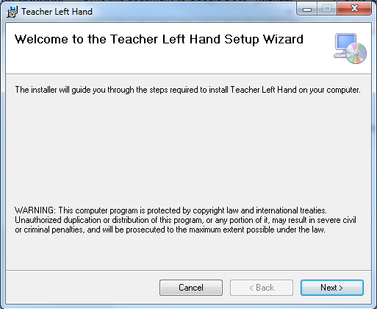

STEP 2 – Choose Installation Folder

* In the next screen, installation option will be displayed
  + 1. Click **Browse** button and select destination folder.
    2. Click **Disk Cost** button to view available disk cost [OPTIONAL]
    3. Select user for installation.

Then click **Next**.

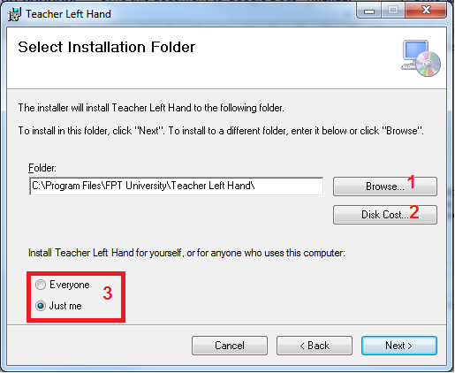

STEP 3 – Confirm Installation

* The following Screen is display, click **Next** to start installation.

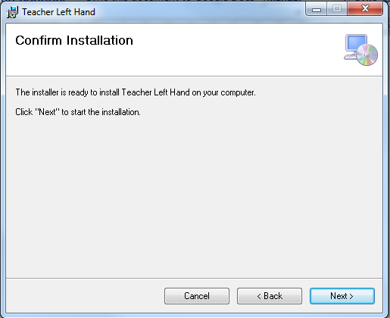

* Wait for installer to finish setup progress.

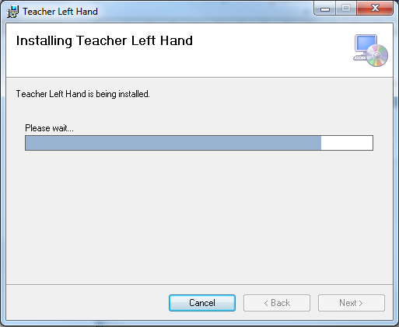

* When finished, the following Screen is displayed. Click **Close.**

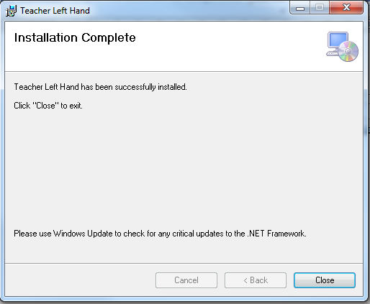

* The program is ready and can be started from:
  + 1. From Desktop: Open from Desktop shortcut

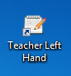

* + 1. From Start Menu: Click Start, click All Program, select Teacher Left Hand program group, click Teacher Left Hand.

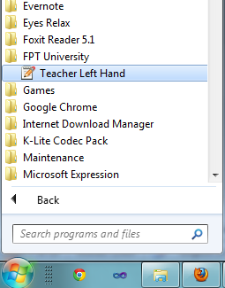

# User’s Guide

## Teacher Left Hand Interface Overview

To open Teacher Left Hand, do one of the following:

* Select Windows Start menu > All Programs > FPT University > Teacher Left Hand
* Double click Teacher Left Hand shortcut on the desktop

### The Ribbon Tab

The Ribbon helps you quickly find the tools and options you need to complete a task. Tools and options are organized into groups that are collected together under specific tabs.

#### Understand the ribbon bar components:

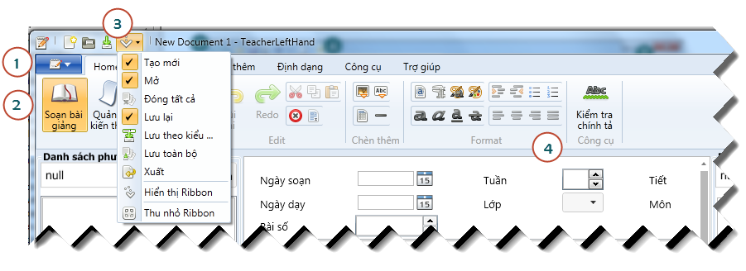

|  |  |  |
| --- | --- | --- |
| Number | Name | Description |
| 1 | Application button | Click the **Application Button** to access basic commands such as New, Open, Close, Close All, Save, Save As, Save All, Export, and Close |
| 2 | Ribbon | Tools and options are located throughout the ribbon and are organized in logical groups. Click icons with down arrows to see more options and effects for a particular tool. |
| 3 | Quick Access Toolbar | Customize the Quick Access Toolbar with the tools and commands used most frequently. Right-click icons and options throughout the ribbon to add to the Quick Access Toolbar. |
| 4 | Ribbon Group | Find groups of related tools and options in the Ribbon. Right click on a tool or option to add it to the Quick Access Toolbar. |

#### Minimize or Maximize the Ribbon from the Quick Access Toolbar

1. Click the **Customize Quick Access Toolbar** down arrow.
2. Select **Minimize Ribbon**.
3. To use the tools and commands while the Ribbon is minimized, click the name of the tab you want to use. The ribbon will appear. Once the canvas is clicked on, the ribbon will minimized again.

*To restore the Ribbon, repeat steps 1-2.*

#### Minimize or Maximize the Ribbon Using the Tabs

1. To quickly minimize the Ribbon, double-click the name of a tab.

### Application button

The **Application Button** helps you access basic commands on Teaching Plan.

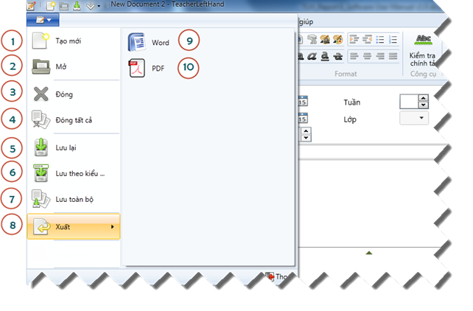

|  |  |  |
| --- | --- | --- |
| Number | Name | Description |
| 1 | New | Click to create a new Teaching Plan. |
| 2 | Open | Click to open a Teaching Plan. |
| 3 | Close | Click to close current selected opening Teaching Plan. |
| 4 | Close All | Click to close all opening Teaching Plans. |
| 5 | Save | Click to save current selected opening Teaching Plan. |
| 6 | Save As | Click to save current opening Teaching Plan as a new file. |
| 7 | Save All | Click to save all current opening Teaching Plans. |
| 8 | Export | Click to export current selected opening Teaching Plan to a specific file type. |
| 9 | Export to Word | Click to export current opening Teaching Plan to Microsoft Word file format. |
| 10 | Export to PDF | Click to export current opening Teaching Plan to PDF file format. |

### Home tab

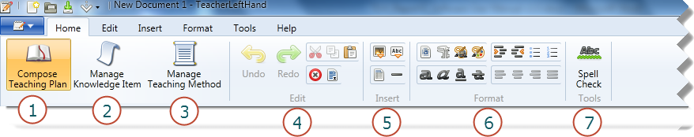

|  |  |  |
| --- | --- | --- |
| Number | Name | Description |
| 1 | Compose Teaching Plan button | Click to go to Compose Teaching Plan Screen |
| 2 | Manage Knowledge Item button | Click to go to Manage Knowledge Item Screen |
| 3 | Manage Teaching Method button | Click to go to Manage Teaching Method Screen |
| 4 | Edit button group | The Edit button group contains the following tools and commands: Undo, Redo, Cut, Copy, Paste, Clear, Select All. |
| 5 | Insert button group | The Insert button group contains the following tools and commands: Insert Image, Insert Table, Insert Text, Insert Horizontal line. |
| 6 | Format button group | The Format button group contains the following tools and commands:  Set Font, Set Font Size, Set Font Color, Set Font Highlight Color,  Indent More, Indent Less, Bullet List, Number List,  Bold, Italic, Underline, Strikethrough, Align Left, Align Center, Align Right, Align Justify. |
| 7 | Tool button Group | The Tool button group contains the following tools and commands:  Spell Check |

### Edit tab

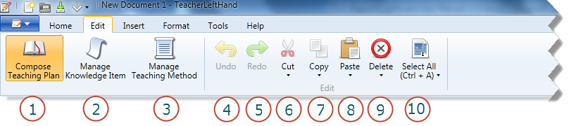



|  |  |  |
| --- | --- | --- |
| Number | Name | Description |
| 4 | Undo button | Click to undo current text editing. |
| 5 | Redo button | Click to redo current text editing. |
| 6 | Cut button | Click to cut selected object |
| 7 | Copy button | Click to copy selected object |
| 8 | Paste button | Click to paste selected object |
| 9 | Delete button | Click to paste selected object |
| 10 | Select All button | Click to select all object in current control. |

### Insert tab

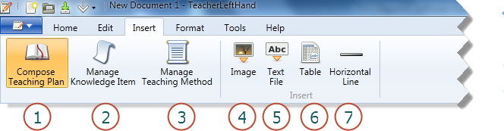

|  |  |  |
| --- | --- | --- |
| Number | Name | Description |
| 4 | Insert Image button | Click to insert image. |
| 5 | Insert Text File button | Click to insert text from a text file. |
| 6 | Insert Table button | Click to insert table. |
| 7 | Insert Horizontal Line button | Click to insert horizontal line. |

### Format tab

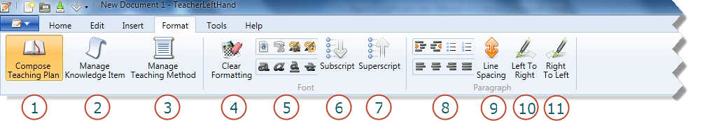

|  |  |  |
| --- | --- | --- |
| Number | Name | Description |
| 4 | Clear format button | Click to clear all text formats. |
| 5 | Font button group | The Font button group contains the following tools and commands:  Set Font, Set Font Size, Set Font Color, Set Font Highlight Color,  Bold, Italic, Underline, Strikethrough, |
| 6 | Subscript button | Click to change selected text to subscript format. |
| 7 | Superscript button | Click to change selected text to superscript format. |
| 8 | Paragraph button group | The Paragraph button group contains the following tools and commands:  Indent More, Indent Less, Bullet List, Number List,  Align Left, Align Center, Align Right, Align Justify. |
| 9 | Line spacing button | Click to format line spacing |
| 10 | Left to Right button | Click to change text input mode to Left to Right |
| 11 | Right to Left | Click to change text input mode to Right to Left |



### Help Tab

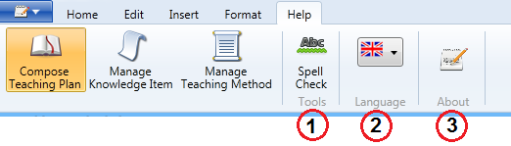

|  |  |  |
| --- | --- | --- |
| Number | Name | Description |
| 1 | Spell Check button | Click to check spelling |
| 2 | Language button | Click to change display language. |
| 3 | About button | Click to view software information |

### Compose Teaching Plan Screen Area:

This Screen is displayed when Compose Teaching Plan button is clicked.

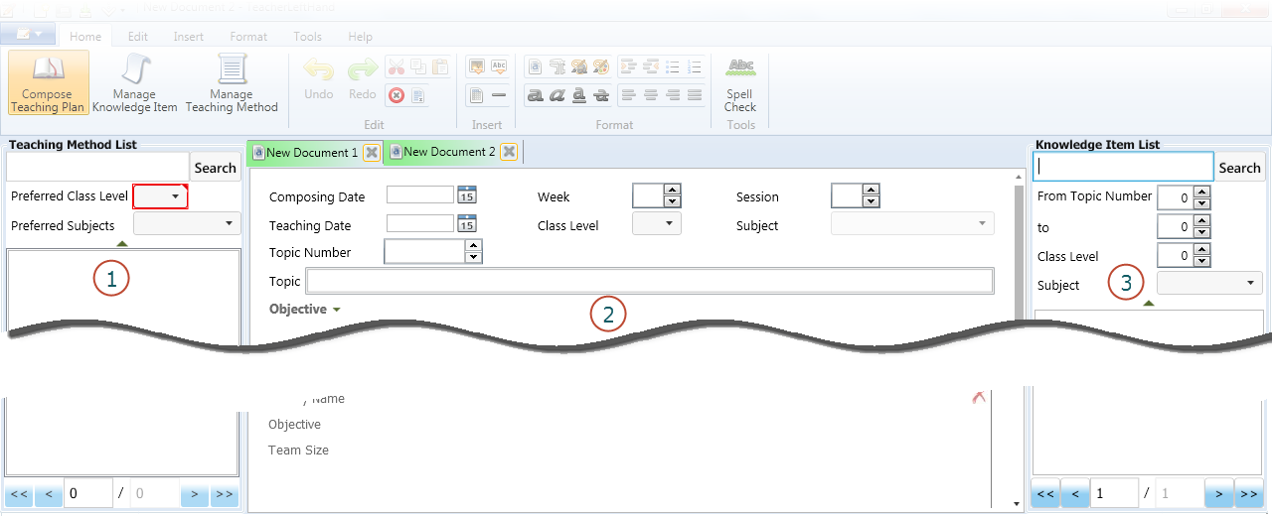

|  |  |  |
| --- | --- | --- |
| Number | Name | Description |
| 1 | Teaching Method List | The Teaching Method List contains the following tools and commands:  Search keyword input, Preferred Class Filter, Preferred Subject Filter, Search button and Teaching Method list. |
| 2 | Teaching Plan Editor | Teaching Plan Editor contains input control for:  Composing Date, Week, Session, Teaching Date, Class Level, Subject, Topic Number, Topic, Objective, Preparation, Activities and Experience Note. |
| 3 | Knowledge Item Editor | Knowledge Item Editor contains the following tools and commands:  Search keyword input, Topic Number start end filters, Class Filter, Subject Filter, Search button and Knowledge Item list. |

### Manage Knowledge Item Screen Area:

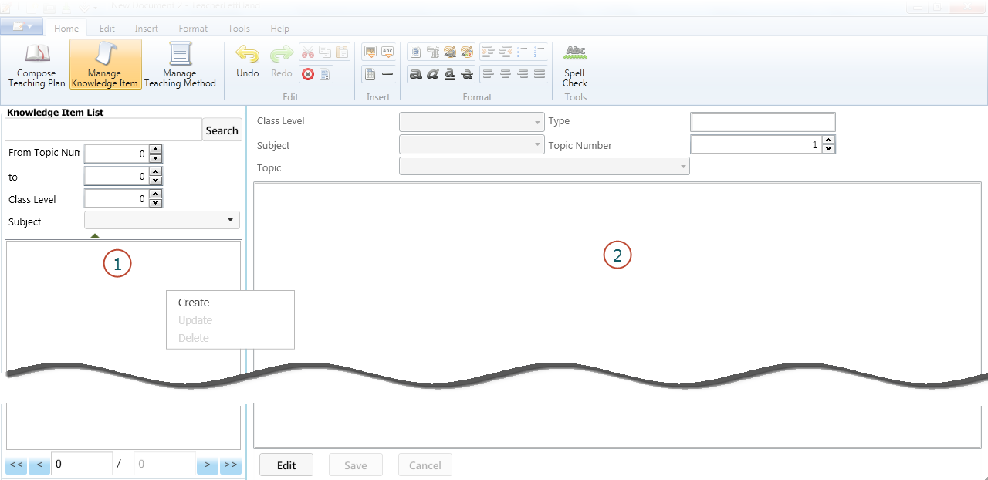

|  |  |  |
| --- | --- | --- |
| Number | Name | Description |
| 1 | Knowledge Item Editor | Knowledge Item Editor contains the following tools and commands:  Search keyword input, Topic Number start end filters, Class Filter, Subject Filter, Search button and Knowledge Item list. |
| 2 | Knowledge Item Editor | Teaching Plan Editor contains inputter for:  Class Level, Type, Subject, Topic Number, Topic and Content.  Knowledge Item Editor also contains button:  Edit, Save, and Cancel buttons. |

### 

|  |  |  |
| --- | --- | --- |
|  |  |  |
|  |  |  |
|  |  |  |



## Working with Knowledge Item

### Add a new Knowledge Item

There are 2 ways to add a new Knowledge Item.

1st way - From Compose Teaching Plan

* 1. Click Compose Teaching Plan button.
  2. Right Click on Knowledge Item list
  3. Select Create menu.

2nd way - From Manage Knowledge Item

* 1. Click Manage Knowledge Item button.
  2. Right Click on Knowledge Item list
  3. Select Create menu.

### Update Knowledge Item

There are 2 ways to update a Knowledge Item.

1st way - From Compose Teaching Plan

* 1. Click Compose Teaching Plan button.
  2. Right Click on selected Knowledge Item on the list
  3. Select Update menu.

2nd way - From Manage Knowledge Item

* 1. Click Manage Knowledge Item button.
  2. Select Knowledge Item on the list
  3. Click Edit button on Knowledge Item Editor.

### Delete Knowledge Item

There are 2 ways to delete a Knowledge Item.

1st way - From Compose Teaching Plan

* 1. Click Compose Teaching Plan button.
  2. Right Click on Knowledge Item list
  3. Select Delete menu.

2nd way - From Manage Knowledge Item

* 1. Click Manage Knowledge Item button.
  2. Right Click on Knowledge Item list
  3. Select Delete menu.

### Search Knowledge Item

* 1. Click Compose Teaching Plan button
  2. OR Click Manage Knowledge Item button.
  3. Input search conditions on Knowledge Item list.
  4. Click Search button.

## Working with Teaching Method

### Add a new Teaching Method

There are 2 ways to add a new Teaching Method.

1st way - From Compose Teaching Plan

* 1. Click Compose Teaching Plan button.
  2. Right Click on Teaching Method list
  3. Select Create menu.

2nd way - From Manage Teaching Method

* 1. Click Manage Teaching Method button.
  2. Right Click on Teaching Method list
  3. Select Create menu.

### Update Teaching Method

There are 2 ways to update a Teaching Method.

1st way - From Compose Teaching Plan

* 1. Click Compose Teaching Plan button.
  2. Right Click on selected Teaching Method on the list
  3. Select Update menu.

2nd way - From Manage Teaching Method

* 1. Click Manage Teaching Method button.
  2. Select Teaching Method on the list
  3. Click Edit button on Teaching Method Editor.

### Delete Teaching Method

There are 2 ways to delete a Teaching Method.

1st way - From Compose Teaching Plan

* 1. Click Compose Teaching Plan button.
  2. Right Click on Teaching Method list
  3. Select Delete menu.

2nd way - From Manage Teaching Method

* 1. Click Manage Teaching Method button.
  2. Right Click on Teaching Method list
  3. Select Delete menu.

### Search Teaching Method

* 1. Click Compose Teaching Plan button or Click Manage Knowledge Item button.
  2. Input search conditions on Teaching Method list.
  3. Click Search button.

## Working with Teaching Plan

### Create new Teaching Plan

**Create a new file**

* 1. Click Application button.
  2. Click New button.
  3. Input Teaching Plan content in new Teaching Plan Editor
  4. Click Application button, then click Save button. (Or press Ctrl +S)

**Add new Activity**

Click on + button ( ) at Activity region to add new activity.

**Delete an Activity**

Click on + button () at on top left corner of activity to delete it.

**Insert a Teaching Method to Activities**.

Drag target Teaching Method and drop on target Activity.

**Insert a Knowledge Item to Activities**

Drag target Knowledge Item and drop on target Teaching Method.

### Open a Teaching Plan

* 1. Click Application button.
  2. Click Open button.
  3. Browse for target file.
  4. Click Open.

### Export Teaching Plan

* 1. Click Application button.
  2. Click Export button.
  3. Select target file format.
  4. Browse for file location
  5. Name the file.
  6. Click Export.

## Teacher Left Hand Options

### Change display language

* 1. Select Help tab.
  2. Click on language combo box.
  3. Select national flag of the language.

# Others

N/A